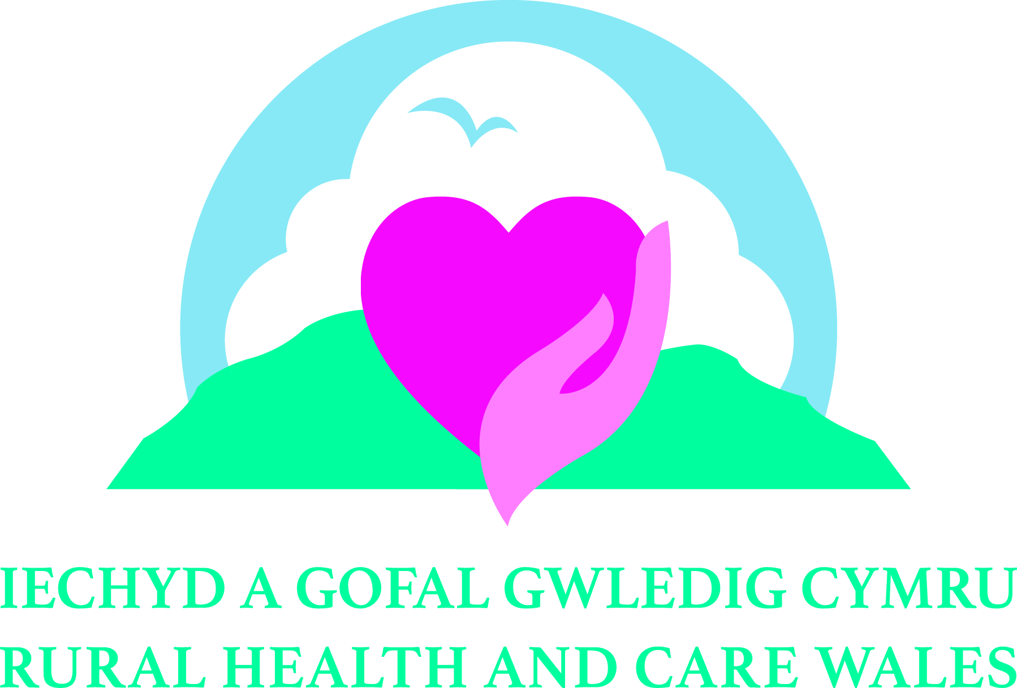 **Rural Health and Care Wales   
 Conference 2022**

***Embracing Change****– welcoming innovation and new ways of delivering Rural Health and Care services*

*14th and 15th November 2023*

CALL FOR PAPERS APPLICATION FORM

|  |  |
| --- | --- |
| Name: |  |
| Job Title: |  |
| Organisation: |  |
| Are you a student? | YES / NO |
| Email Address: |  |
| Telephone Number: |  |
| Address: | Postcode: |
| Conference Strand  (please tick one): | □ The delivery of Integrated Health and Care services in Rural areas, including cross-sector, multi-agency and / or multi-disciplinary working  □ The role of Rural Communities and unpaid Carers in Health and Care  □ Advances in Artificial Intelligence (AI), Telehealth / Telemedicine and the remote delivery of Health and Care services in Rural areas  □ Social / Green Prescribing and the impact of Art, Crafts and other non-clinical interventions on Health and Wellbeing  □ Recruitment and Retention of Health and Care professionals in Rural areas  □ Education, Training and Continuous Professional Development for Health and Care professionals working in Rural areas |
| Type of Presentation: | □ Paper *(20 minute presentation)* □ Poster |
| Title of Presentation: |  |
| Abstract –  *300 words max.* |  |
| Keywords / messages:  *(6 max.)* | 1.  2.  3.  4.  5.  6. |
| Co-presenter(s) information:  *(if applicable)* | 1. Name:   Job Title:  Organisation:   1. Name:   Job Title:  Organisation:   1. Name:   Job Title:  Organisation: |
| Biography of each speaker, including yourself:  *(150 words max. per person)* |  |
| Date of submission of application: |  |
| Signature: |  |

Please return completed form to [anna.prytherch@wales.nhs.uk](mailto:anna.prytherch@wales.nhs.uk)

by **17.00 GMT, Friday 22nd September 2023**